Mulu/AnswerBite: Engineering Test

Congratulations! We’re glad to have you here in this stage of the process. We need to test your code expertise and your ability to come up with a solution. We’re going to evaluate your solution using the following criteria:

* Solution actually works.
* Code is easy to read.
* Code is testable.
* Solution is well documented.

This document explains the step-by-step specification for developing a solution. We’ve detailed what are the resources you can use to build your solution but you can use any extra resource you consider properly to achieve the results.

# Specification

Please first read this document to understand how the evaluation-solution process works. You need to build a solution using the following:

* NodeJS+ExpressJS
* ReactJS
* MVC (Model View Controller) or any other model for RestAPIs you consider
* MongoDB
* Javascript+AJAX
* Unit tests for your methods.
* Provide a README file in your solution with the process to replicate the environment, listing the 3rd party libraries or resources needed to run it and a brief description about how it works.

The system has 2 lists of users: Agents and Contacts. Agents are the users who want to connect with Contacts for offering professional services. Contacts are users who are being reached by Agents to solve specific problems. Each user type has (first name, last name, age, gender, zip code) but only Agents have 1 extra field (profession). Professions are (Corporate Finance, Commercial Banking, Investment Banking, Hedge Funds, Financial Planning).

## Problem

How can the system match each Agent with *n* Contacts based on location (distance)?

E.g.:

* 1st Match sorted by distance: Agent John Smith (San Francisco) got a match with Contact Jane Doe (San Francisco).
* 2nd Match sorted by distance: Agent John Smith (San Francisco) got a match with Contact John Doe (Los Angeles).

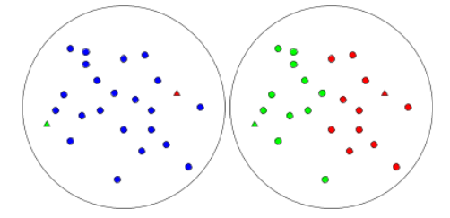

Figure 1. Initial state and expected result after running the algorithm.

Contacts (blue circles). Agents (green and red triangles).

## GUI

* A view for User Login.
* A view for User Details.
* A view for Listing the matches they got.

## What do we expect?

1. A Github repository with your solution.
2. README file.
3. Unit tests.

**Note**: You can ask questions before sending your solution